Lesson Plan Template
Course Name: Week: Date:
Course outcome/s:

- Essential Employability Skills:

- Lesson objectives:

- Formative Assessment/s: Time:

- Summative Assessment: Time:

- Motivation: Materials & Delivery: Time:

- Comprehension: Materials & Delivery: Time:

- Practice: Materials & Delivery: Time:

- Application: Material & Delivery: Time:

Accommodations required:

Comments:

Things to remember and repeat:

Things to do differently:

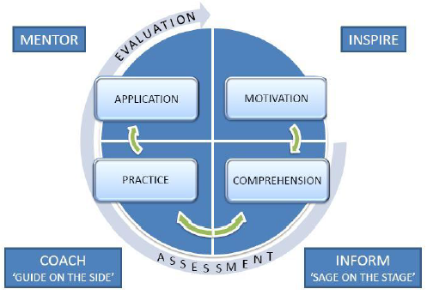
The Learning Cycle

